Training

guide

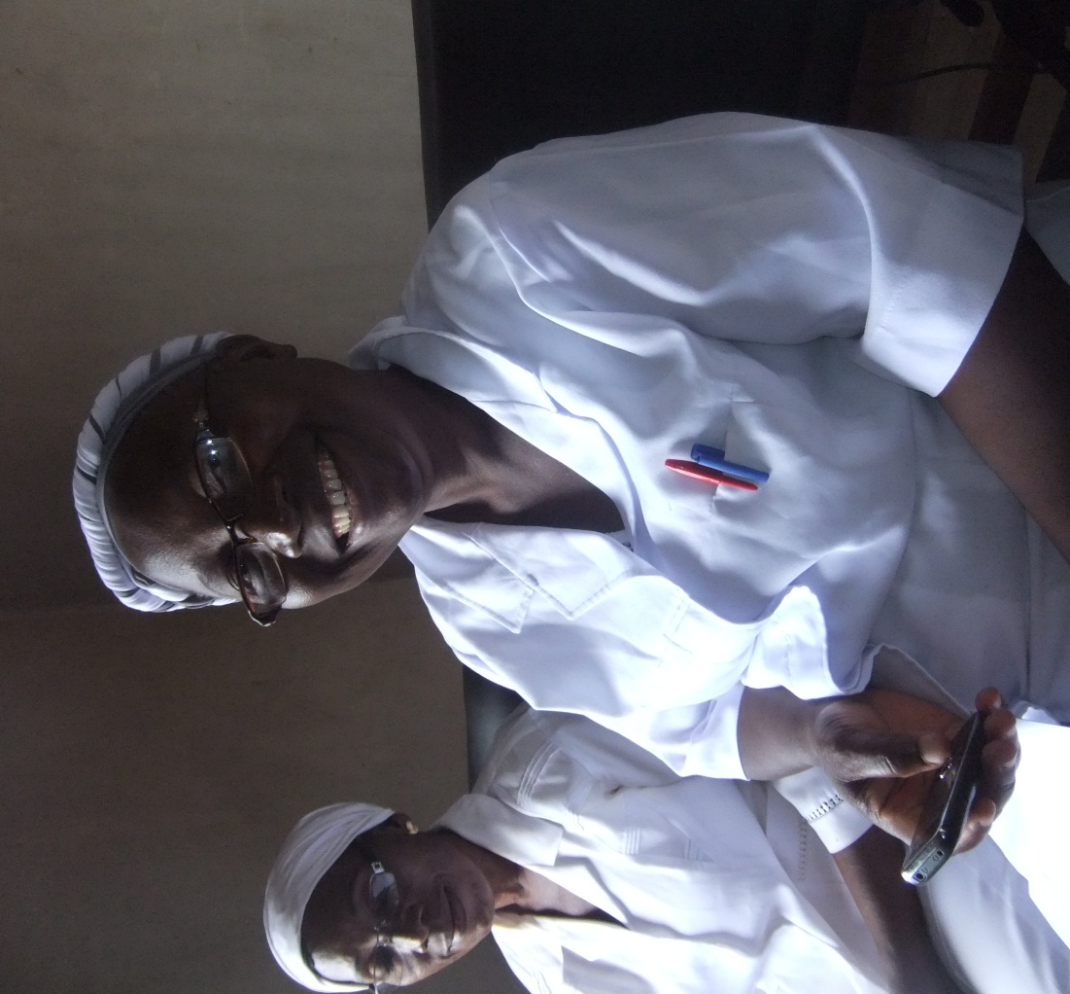
m4change
ANC Clinical Decision-making Mobile Application Abuja, Nigeria

Training Schedule
Goals:
- Understand basic mobile phone and CommCare operations
- Go over ANC Visit module and forms
- Enter test clients to understand skip logic and diagnosis
- Engage with multimedia

Part One
Activity | Estimated Time
- Icebreakers and Introductions | 20 min
- Overview of ANC visits and m4change project | 20 min
- Review Basic Phone Operations and logging into CommCare | 10 min
- Go over ANC Visit Module  - Booking form  - Follow-up form  - Palpation/lab form  - Modify/close client form | 10 min
- Work in partners practicing with test cases | 1 hour
- Questions and Answers | 30 min
- Lunch Break | 40 min
Part Two
Activity | Estimated Time
- Work in partners practicing with test cases | 1 hour
- Go over Health Talks Module  - Explore with partners | 20 min
- Go over Facility Reports Module  - Practice with test cases | 30 min
- Questions and Answers | Remaining Time

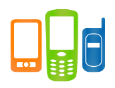
Basic Phone Operations

Name | Image | Description | Key Points
- Center Button |  | Used for basic navigation like scrolling up and down or left to right | - Center is “Ok”  - “Ok” also takes you to the “Main Menu”
- Key Pad | 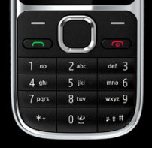 | Used for entering letters and numbers | - Decimal/Period is in the bottom left  - “0” key enters a space
- Red Button | 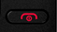 | Turns phone on/ off, hangs up calls, or exits application | - Exits out of CommCare  - Make sure you logout of CommCare before exiting
- Green Button |  | Answers calls, selects options | - Short cut to CommCare is on soft button above
- Soft Keys |  | Selects options, navigates within CommCare application | - Navigate in CommCare  - Selecting options will allow you to do things like sort a case list
- Settings |  | Changes phones settings such as date and time | - Can also change phone’s language settings
- Applications |  | Enters applications like SD card, Games Folder and Collection Folder | - Where CommCare “App” is stored  - Contains SD /memory card
- Collection Folder |  | Contains CommCare Application (Right next to Facebok) | - Folder where CommCare Application is stored
- CommCare Application |  | Opens CommCare Application | - Clicking on this opens CommCare

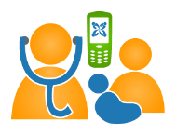
Managing Cases in CommCare

Name | Image | Description | Key Points
- Login Screen |  | Logs user into CommCare with secure password | - Passwords are numeric only  - If phone is lost username and password can be changed
- Modules | 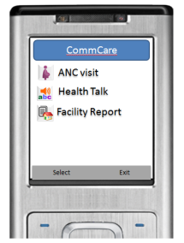 | Sections of the Application that allow you to do different things like ANC care or Health Talks | - Each module contains separate “forms” that you fill out
- Syncing with Server | Sync with Server (you have 1 unsent form) | Sends forms to the cloud based server, retrieves any new information that may have been added to the phone | - Important to do this at the end of every ANC day
- Forms | 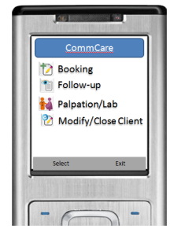 | Where you enter or modify client information | - “Booking” registers a new client  - “Follow-up” is for returning clients  - “Closing” a client removes them from your case list screen
- Case List |  | Shows list of clients in the phone | - Options key sorts the list  - Find allows you to search for a client  - The total number of clients is on the top of the screen
- Case Details |  | All of the details that would be on an ANC card for each client | - Has previously entered data  - Must select “Ok” before moving on to follow-up form or palpation/lab form

Using Multimedia

Name | Image | Description | Key Points
- Media Center |  | Turns up volume | - Located under “Menu” key
- Hash tag |  | Plays audio in forms | - Pressing will play embedded audio clips
- Health Talks Module |  | Images and audio clips to help with giving health talks at ANC visits | - Various topics related to ANC
- Topic Forms |  | Yes/No as to whether or not you would like to play more audio clips | - Use as supplements to health talks  - Different topics each with multiple audio clips and images

Frequently Asked Questions

What is CommCare?
CommCare Mobile sends data over standard phone networks for inspection on the web in real-time. With complex form logic and data validation, CommCare supports a variety of projects, from simple surveys to complex counseling forms.

I keep receiving messages on the EDD of clients past 40 weeks on the phone, how do I make them stop?
You may contact the Pathfinder International Project Manager to help you cancel these services or to handle any issues with data bundles and phone service.

The Date and Time on my phone are incorrect. How do I fix this?
Step 1: In the home screen of the phone, press the center button to enter the menu screen.
Step 2: Navigate to “Settings”. Press the center button.
Step 3: Come down to “Date and Time”. Press the center button.
Step 4: Press the center button on “Date and Time Settings”.
Step 5: Type in the current date and time. Once you are finished, press the center button to save the new date and time.

The volume on my phone is very low. How do I increase it?
Step 1: In home screen of the phone, press the center button to enter the menu screen.
Step 2: Navigate to Media. Press the center button.
Step 3: Scroll down to “Media Player” and Press the center button.
Step 4: Press the center button “Go to Media Player”.
Step 5: Keep pressing the top button till you see the green bar on the bottom right fill up.

I entered the registration details of a client today. I am not sure if the case was registered in CommCare. How can I check?
If you have correctly registered a case, you will see the name of the case appear in your case list. Select any form other than the registration form. In the case list, scroll down to the bottom. Newly registered cases will appear at the bottom of this list.

Practice Client Cases

CASE 1:
AISHA BAGUDU is 23 and this is her first pregnancy, she did islamic education only but understands English, she suddenly started having fever and headaches and nothing more. She has no prior history of any illness.
Other Information- She is a house wife, her husband’s name is Mohammed Gambo and he is a trader. Her last period started on 15th March 2012. Her number is 08031111111. You could not measure her height because the height scale was missing. Her current weight is 55.5kg. BP=120/70. TT1 given. Baby fetal rate normal, fundus length was measured to be 36cm. No Protein or Glucose in her urine. There was not test KIT for HIV testing.

CASE 2:
AISHA came back 2weeks later still having the fever and joint pain this time with severe vomiting and weakness, she now weighs 60kg, her bp was still same 120/70. Every other thing was same except that she has done the HIV test and her result was negative.
CASE 3:
NGOZI CHIMA is 32 and this is her 3rd pregnancy, but she had only one successful delivery. Her mobile is 08076666666. She works with a cyber café. She says she has no spouse and has completed her secondary education. She has a history of Heart disease. Some persons in her family has high BP. She had anemia during her last pregnancy and had to be transfused. Her LMP was 16th August. Her height was 1.6m, and weight 50kg. BP 110/70. She had TT1 immunization and HCT. She feels dizziness, and has pale look even though she has no fever.
CASE 4:
NGOZI returns for her next appointment with weight now 55kg and , and BP 123/85. She experiences breathlessness too often and most times its as if her heart was failing her.
CASE 5:
KEMI is 3months pregnant and does not know her exact LMP, her mobile is 08038888888. She is 24year old graduate and is not currently working. This is her first pregnancy. She is 1.6m high. Her husband Gbenga Arumi works in a bank. She has been having high BP, and there was protein in her urine. Her current BP reads 162/100. She arrives the facility cheerful and fine. She weighs 65kg. She had her TT1, and was tested for HIV and was negative.
CASE 6:
CELESTINA has the same data with Kemi except that her current BP reads 146/90. She arrives the facility with severe headaches and blurred vision. She weighs 65kg. She had her TT1, and was tested for HIV and was negative.

